Summit Academy
School Supplies
Needed for Kindergarten

6 pcs. Plastic Envelope (clear/transparent)
1 Box of Crayons (32 pieces)/ Colored pencils
Colored Paper
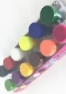
Drawing Paper
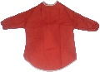
Watercolor Paint Bottle Set
Apron
Small Dry Erase White Board and Marker
1 pack ofA4 copy paper (for homework worksheets)
Staedtler/ Faber Castell Pencils & Erasers
Kleenex tissue and pocket hand sanitizer
Wet wipes (for Preschool)
Scissor
Sharpener
Stick Glue
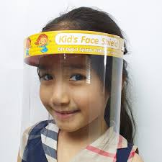
Pencil Case
Face shield (to be worn every day at school)
10 pcs. Extra Face Mask in a sealed pack

Don’t forget to label everything brought to school with child’s name and Family Number. Also, provide an extra set of clothing (shirt, pants, underwear, and socks) in a zip lock bag in case of urgent situation, and bring toothbrush, toothpaste, and face towel. No toys or playthings allowed at school.

Thank You!
Class Teacher

Child’s Name: _________________________ Grade & Section____________
Received by: _________________________ Date: ____________________

